ANN Predictive Modelling Documentation

Customer Churn Prediction Project

1. Introduction
The purpose of this predictive modelling component is to develop an Artificial Neural Network (ANN) model for predicting customer churn. Customer churn refers to customers who discontinue or terminate a service.
The ANN model is implemented as a supervised binary classification model. It uses customer-related features as input and predicts whether a customer is likely to churn or not churn.
The predictive modelling implementation was developed using Python with Pandas, NumPy, Scikit-learn and TensorFlow/Keras.
The main objectives of the predictive modelling stage are to:
- Define an appropriate ANN architecture for customer churn prediction.
- Train the ANN using the provided pre-processed dataset.
- Evaluate the predictive performance of the trained model.
- Generate predictions for unseen test data.
- Save the trained ANN model for future use.
- Produce evaluation outputs including classification metrics, confusion matrix and ROC-AUC.

2. Dataset Description
The ANN model was trained using the pre-processed customer churn dataset provided by the Data Engineering component of the project.
The dataset contains 7,043 customer records and 13 columns. Twelve columns are used as predictor variables and one column, Churn, is used as the target variable.
Dataset Summary
Item | Description
Number of records | 7,043
Total columns | 13
Predictor variables | 12
Target variable | Churn
Target classes | 0 = No Churn, 1 = Churn
No Churn records | 5,174
Churn records | 1,869
Missing values | 0
Duplicate rows detected | 302
The target variable contains:
- 5,174 No Churn customers
- 1,869 Churn customers
This indicates that the dataset has a class imbalance, with fewer customers belonging to the Churn class.
The model therefore uses class weighting during training to give greater importance to the minority Churn class.

3. Input Features
The following 12 features were used as input variables for the ANN model:
- gender
- SeniorCitizen
- Dependents
- tenure
- PhoneService
- MultipleLines
- MonthlyCharges
- InternetService_DSL
- InternetService_Fiber optic
- Contract_Month-to-month
- Contract_One year
- Contract_Two year
The Churn column was excluded from the input features because it is the target variable being predicted.
The supplied dataset already contains numerical and encoded variables. Therefore, the script confirmed that there were no non-numeric feature columns requiring additional one-hot encoding during this modelling run.
The tenure and MonthlyCharges variables were already scaled in the dataset supplied by the Data Engineering team. Therefore, an additional StandardScaler was not applied in the ANN script to avoid unnecessarily scaling already pre-processed data.

4. Data Preparation
The following data preparation steps were performed before training the ANN:
- The pre-processed CSV dataset was loaded using Pandas.
- Dataset dimensions, column names, missing values and duplicate records were checked.
- The Churn column was identified as the target variable.
- The target variable was confirmed to contain binary values of 0 and 1.
- The target variable was separated from the predictor variables.
- The 12 predictor variables were used as the input features.
- The feature data was converted to floating-point values.
- The dataset was divided into training and testing datasets.
- Stratified sampling was used to maintain the class distribution.
- Class weights were calculated to address the imbalance between Churn and No Churn classes.
Train-Test Split
An 80:20 train-test split was used.
Dataset | Records | Features
Training set | 5,634 | 12
Testing set | 1,409 | 12
The training data was further divided using a 20% validation split during ANN training.

5. Handling Class Imbalance
The dataset contains considerably more No Churn customers than Churn customers.
The class distribution was:
Class | Number of Customers
No Churn (0) | 5,174
Churn (1) | 1,869
To address this imbalance, balanced class weights were calculated using Scikit-learn.
The calculated weights were:
Class | Class Weight
No Churn (0) | 0.6806
Churn (1) | 1.8843
The higher weight assigned to the Churn class means that errors involving Churn customers have greater influence during model training.
This approach helps the ANN pay greater attention to the minority class and improves its ability to identify customers who are likely to churn.

6. Defined ANN Architecture
The ANN was designed as a fully connected feed-forward neural network for binary classification.
The architecture consists of:
- An input layer containing 12 input features.
- Three fully connected hidden layers.
- ReLU activation functions in the hidden layers.
- Two Dropout layers for regularisation.
- A single-neuron output layer.
- Sigmoid activation in the output layer.
ANN Architecture
Layer | Configuration | Activation | Parameters
Input Layer | 12 features | — | —
Hidden Layer 1 | 64 neurons | ReLU | 832
Dropout Layer 1 | 30% dropout | — | 0
Hidden Layer 2 | 32 neurons | ReLU | 2,080
Dropout Layer 2 | 20% dropout | — | 0
Hidden Layer 3 | 16 neurons | ReLU | 528
Output Layer | 1 neuron | Sigmoid | 17
Total | — | — | 3,457
The model contains 3,457 trainable parameters and no non-trainable parameters.
ANN Architecture Flow
The architecture can be represented as:
12 Input Features
│
▼
Dense Layer
64 Neurons
ReLU Activation

▼
Dropout
30%
▼

Dense Layer
32 Neurons
ReLU Activation

▼
Dropout
20%
▼

Dense Layer
16 Neurons
ReLU Activation

▼

Output Layer
1 Neuron
Sigmoid

▼
Churn Probability

▼
Churn / No Churn

7. Rationale for ANN Architecture
The architecture was selected to provide sufficient capacity to learn nonlinear relationships between customer characteristics and churn behaviour while maintaining a relatively compact model.
Input Layer
The input layer contains 12 neurons, corresponding to the 12 predictor variables.
First Hidden Layer
The first hidden layer contains 64 neurons with ReLU activation.
This layer provides the network with sufficient capacity to learn relationships between the input customer characteristics.
Dropout Layer
A dropout rate of 30% was applied after the first hidden layer.
Dropout randomly deactivates a proportion of neurons during training and is used as a regularisation technique to reduce the risk of overfitting.
Second Hidden Layer
The second hidden layer contains 32 neurons using ReLU activation.
The reduction from 64 to 32 neurons allows the network to progressively learn more compact representations of the input data.
Second Dropout Layer
A dropout rate of 20% was applied after the second hidden layer.
This provides additional regularisation during training.
Third Hidden Layer
The third hidden layer contains 16 neurons using ReLU activation.
This layer further transforms the learned representations before the final prediction.
Output Layer
The output layer contains a single neuron with a sigmoid activation function.
The sigmoid function produces a probability between 0 and 1 representing the predicted probability of churn.
A threshold of 0.50 was used:
Probability >= 0.50 → Churn
Probability < 0.50 → No Churn

8. Model Compilation
The ANN was compiled using the Adam optimiser and binary cross-entropy loss function.
Parameter | Configuration
Optimiser | Adam
Loss function | Binary Cross-Entropy
Hidden activation | ReLU
Output activation | Sigmoid
Training metric | Accuracy
Maximum epochs | 100
Batch size | 32
Binary Cross-Entropy
Binary cross-entropy was selected because the ANN performs binary classification where the target consists of two classes: Churn and No Churn.
Adam Optimiser
The Adam optimiser was used to update the neural network weights during training. Adam is widely used for neural network optimisation because it adapts the learning rate for individual parameters.

9. Early Stopping
Early stopping was implemented to reduce unnecessary training and help prevent overfitting.
The configuration was:
Parameter | Value
Monitoring metric | Validation loss
Patience | 8 epochs
Restore best weights | Yes
Maximum epochs | 100
During the latest recorded training run, the model trained through 19 epochs before training stopped because the validation loss did not improve sufficiently according to the early stopping criteria.
The best model weights were restored after training.

10. ANN Training Results
The latest successful training run produced the following results:
Epoch | Training Accuracy | Training Loss | Validation Accuracy | Validation Loss
1 | 0.6312 | 0.5989 | 0.7374 | 0.5018
2 | 0.7242 | 0.5490 | 0.7223 | 0.5267
3 | 0.7167 | 0.5358 | 0.7169 | 0.5232
4 | 0.7098 | 0.5400 | 0.7178 | 0.5167
5 | 0.7244 | 0.5333 | 0.7249 | 0.5124
6 | 0.7224 | 0.5284 | 0.7232 | 0.5148
7 | 0.7291 | 0.5264 | 0.7400 | 0.4939
8 | 0.7273 | 0.5247 | 0.7178 | 0.5281
9 | 0.7240 | 0.5215 | 0.7267 | 0.5003
10 | 0.7218 | 0.5257 | 0.7249 | 0.5112
11 | 0.7266 | 0.5244 | 0.7400 | 0.4796
12 | 0.7375 | 0.5192 | 0.7178 | 0.5191
13 | 0.7262 | 0.5259 | 0.7285 | 0.5015
14 | 0.7318 | 0.5169 | 0.7196 | 0.5110
15 | 0.7302 | 0.5190 | 0.7178 | 0.5100
16 | 0.7258 | 0.5159 | 0.7276 | 0.5011
17 | 0.7331 | 0.5187 | 0.7285 | 0.5105
18 | 0.7360 | 0.5146 | 0.7249 | 0.5059
19 | 0.7320 | 0.5138 | 0.7178 | 0.5152
The highest validation accuracy recorded during this run was 74.00%, achieved at Epochs 7 and 11.
The lowest validation loss was 0.4796, achieved at Epoch 11.
The training process was automatically controlled using early stopping.

11. Test Dataset Evaluation
After training, the model was evaluated against the independent test dataset containing 1,409 records.
The latest test results were:
Metric | Result
Test Loss | 0.5008
Accuracy | 74.10%
Precision | 50.85%
Recall | 71.93%
F1 Score | 59.58%
ROC-AUC | 80.86%
These results demonstrate that the ANN is capable of identifying meaningful patterns associated with customer churn.
The ROC-AUC score of 0.8086 also indicates good discriminatory capability between churn and non-churn customers.

12. Classification Report
The classification report provides detailed performance for each class.
Class | Precision | Recall | F1-Score | Support
No Churn | 0.88 | 0.75 | 0.81 | 1,035
Churn | 0.51 | 0.72 | 0.60 | 374
Accuracy | — | — | 0.74 | 1,409
Macro Average | 0.69 | 0.73 | 0.70 | 1,409
Weighted Average | 0.78 | 0.74 | 0.75 | 1,409
Interpretation
The model achieved an overall accuracy of approximately 74%.
No Churn Class
- Precision = 88%
- Recall = 75%
- F1-score = 81%
The model performs strongly when identifying customers who do not churn.
Churn Class
- Precision = 51%
- Recall = 72%
- F1-score = 60%
The churn recall of 71.93% is particularly important from a business perspective. It means that the model successfully identified approximately 72% of customers who actually churned in the test dataset.
However, the churn precision of 50.85% indicates that a considerable number of customers predicted to churn did not actually churn.

13. Confusion Matrix
The confusion matrix generated by the latest ANN run was:
Actual / Predicted | No Churn | Churn
No Churn | 775 | 260
Churn | 105 | 269
The results can be interpreted as follows:
- 775 True Negatives: Customers who did not churn and were correctly predicted as No Churn.
- 260 False Positives: Customers who did not churn but were predicted as Churn.
- 105 False Negatives: Customers who churned but were predicted as No Churn.
- 269 True Positives: Customers who churned and were correctly predicted as Churn.
The 105 false negatives are particularly important for customer retention because these represent churners who were missed by the model.
The model correctly identified 269 out of 374 actual churn customers, resulting in a churn recall of approximately 71.93%.

14. ROC-AUC Evaluation
The ANN achieved a ROC-AUC score of 0.8086.
ROC-AUC measures the model's ability to distinguish between Churn and No Churn customers across different classification thresholds.
An AUC of approximately 0.81 indicates that the model has a good level of discriminatory ability and performs substantially better than random classification.
The ROC curve generated by the Python script is saved as:
Results/roc_curve.png

15. Model Performance Interpretation
The final ANN model achieved:
- 74.10% accuracy
- 50.85% precision
- 71.93% recall
- 59.58% F1-score
- 80.86% ROC-AUC
The use of class weighting helped the model pay greater attention to the minority Churn class.
The relatively high churn recall of 71.93% is beneficial for the business objective because identifying customers at risk of leaving can allow the organisation to take proactive retention measures.
The model identified 269 of the 374 actual churn customers in the test dataset.
However, the precision of 50.85% indicates that some customers classified as potential churners would not actually churn. This could result in unnecessary retention efforts.
Therefore, future improvements could focus on optimising the classification threshold according to the business cost of false positives and false negatives.

16. Model Deliverables
The predictive modelling implementation produces the following deliverables.
Trained ANN Model
Models/customer_churn_ann_model.keras
This is the trained Keras ANN model and can be loaded later without retraining the model.
Python Training Script
churn_predictive_model.py
The Python script contains the complete workflow including:
- Dataset loading
- Dataset inspection
- Feature preparation
- Train-test splitting
- ANN architecture definition
- Model compilation
- Class weighting
- Model training
- Early stopping
- Prediction
- Performance evaluation
- Confusion matrix generation
- ROC curve generation
- Model saving
Classification Report
Results/classification_report.txt
This file contains the calculated classification metrics and class-level performance.
Confusion Matrix
Results/confusion_matrix.png
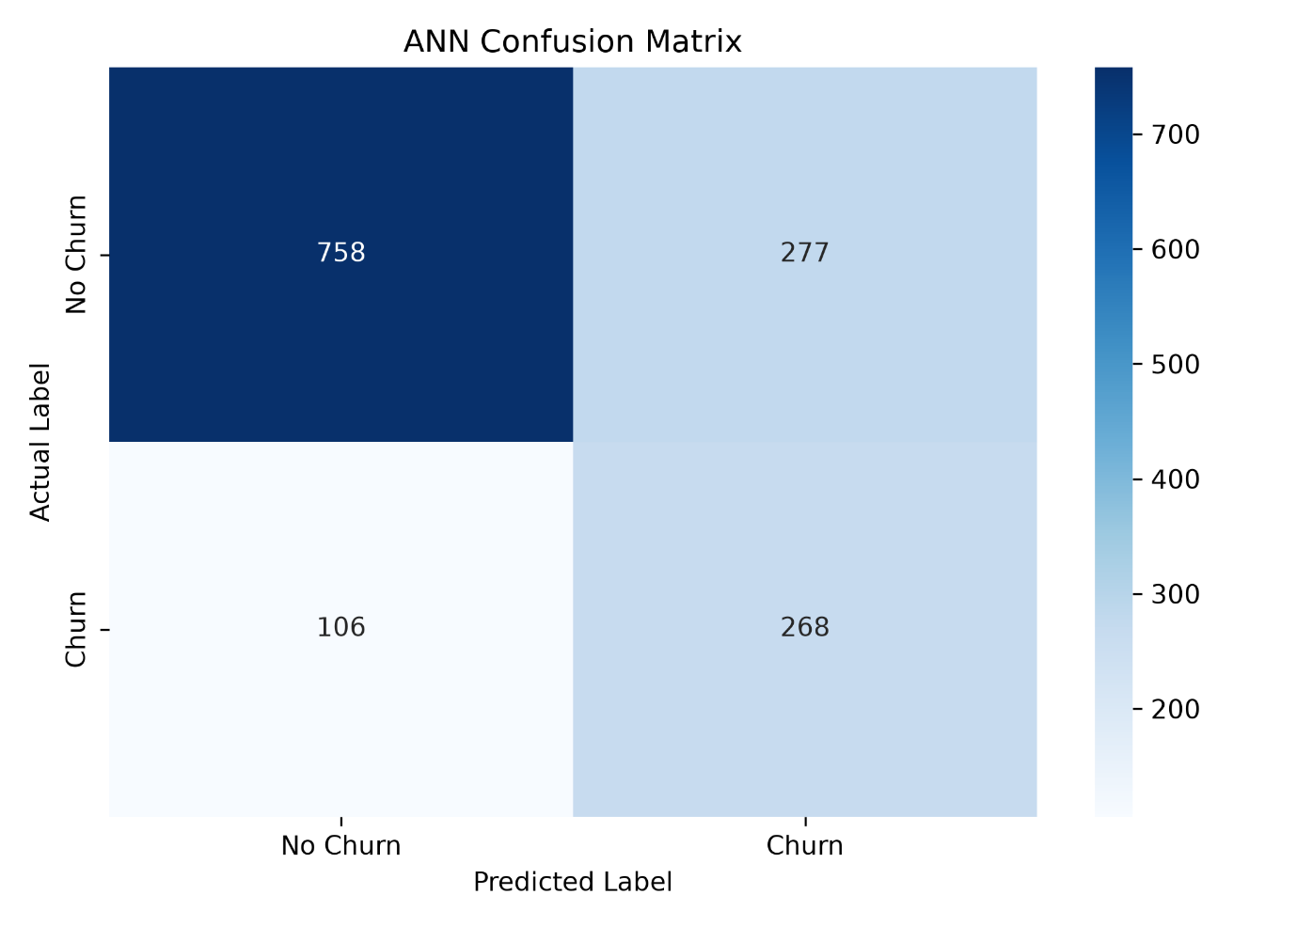

This image visually represents the model's classification results.
Training and Validation Accuracy
Results/training_validation_accuracy.png
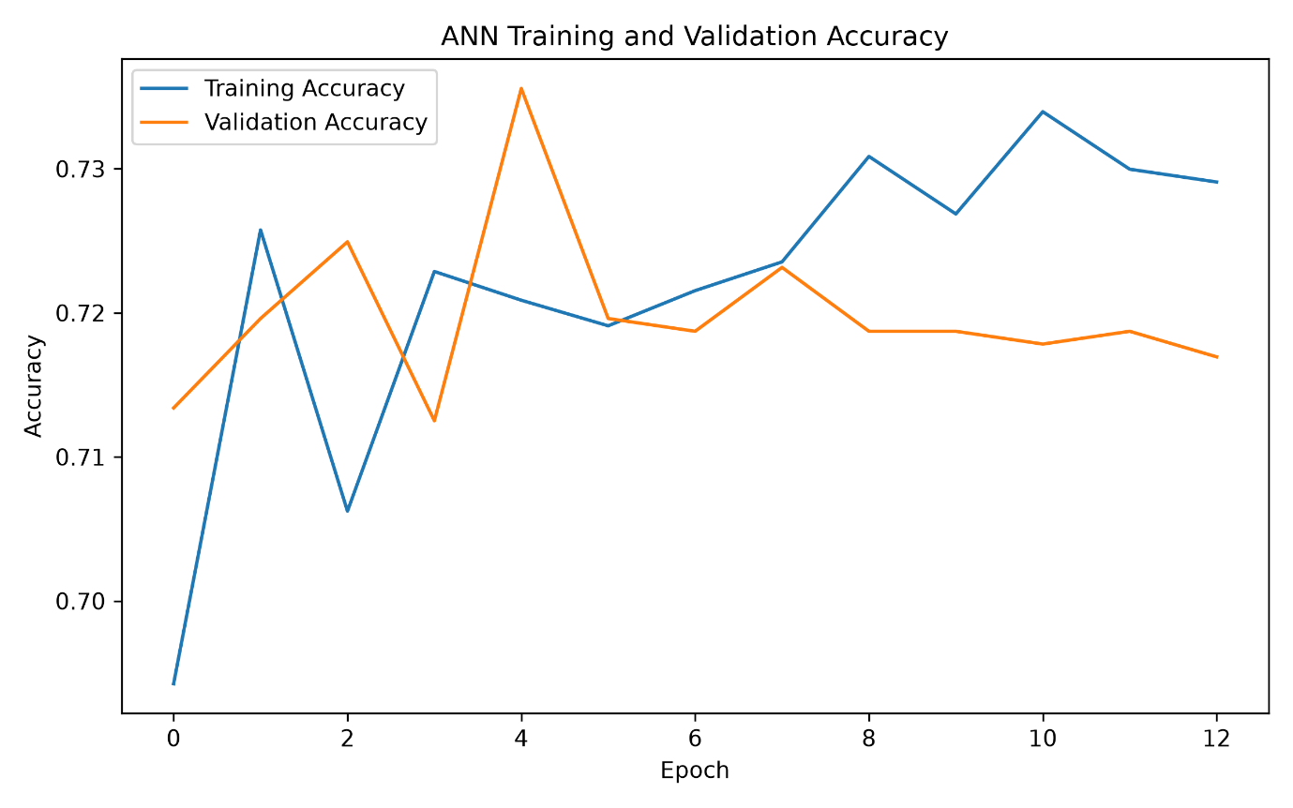

This graph shows the training and validation accuracy across epochs.
Training and Validation Loss
Results/training_validation_loss.png
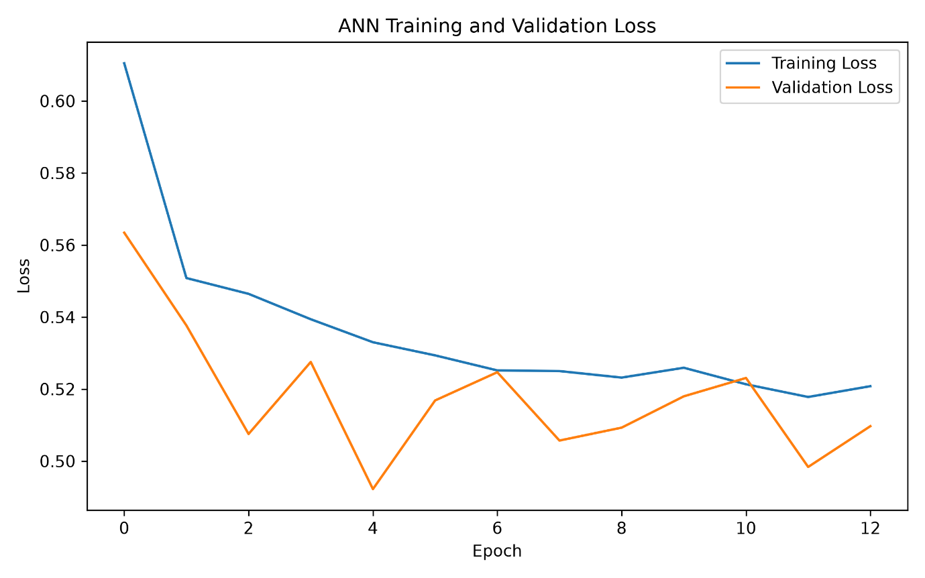

This graph shows the training and validation loss across epochs.
ROC Curve
Results/roc_curve.png
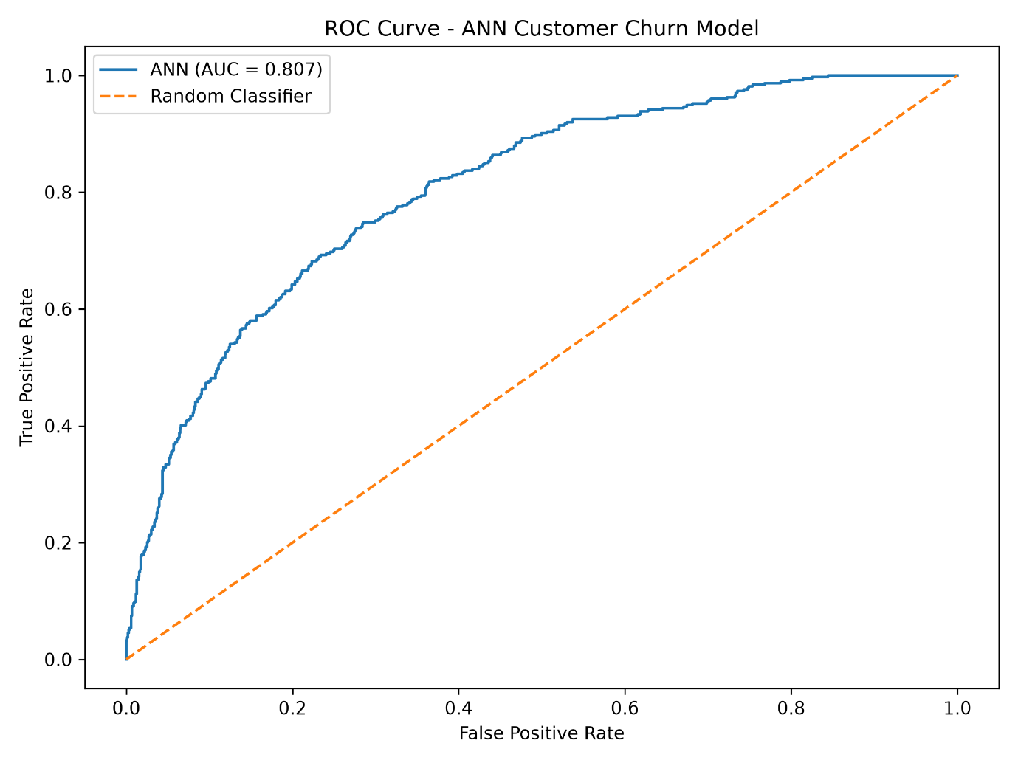

This graph shows the ROC curve and the model's ROC-AUC value.
Prediction Results
Results/ann_predictions.csv
This file contains:
- Actual churn value
- Predicted churn value
- Churn probability
Model Metrics
Results/ann_model_metrics.csv
This file contains the final:
- Accuracy
- Precision
- Recall
- F1-score
- ROC-AUC

17. Recommended Folder Structure
All predictive modelling deliverables stored inside a folder named:
Predictive_Modeling
The recommended structure is:
Predictive_Modeling/

├── ANN_Predictive_Modeling_Documentation.docx

├── churn_predictive_model.py

├── ANN_Predictive_Modeling.ipynb

├── Data/
│ └── customer_churn_preprocessed_Data.csv

├── Models/
│ └── customer_churn_ann_model.keras

└── Results/
├── classification_report.txt
├── confusion_matrix.png
├── training_validation_accuracy.png
├── training_validation_loss.png
├── roc_curve.png
├── ann_predictions.csv
└── ann_model_metrics.csv
This folder structure ensures that the ANN architecture documentation, source code, trained model, dataset and evaluation outputs are organised together as a complete predictive modelling deliverable.

18. Limitations and Potential Improvements
Although the ANN demonstrates useful predictive performance, several areas could be considered for future improvement.
Dataset Duplicates
The dataset inspection identified 302 duplicate rows. The current modelling script reports these duplicates but does not remove them.
The treatment of these records should be confirmed with the Data Engineering team before using the model in a production environment.
Class Imbalance
Although class weighting was used to address the imbalance, the model still produces a considerable number of false-positive predictions.
Further imbalance-handling techniques could be investigated.
Hyperparameter Optimisation
The model could be further optimised by experimenting with:
- Number of hidden layers
- Number of neurons
- Dropout rates
- Learning rate
- Batch size
- Number of epochs
- Early stopping patience
Classification Threshold
The current classification threshold is 0.50.
This threshold could be adjusted based on the business cost associated with false positives and false negatives.
For example, if identifying potential churners is more important than avoiding false alarms, a lower threshold could potentially increase churn recall.
Model Comparison
The ANN could also be compared with other classification approaches such as:
- Logistic Regression
- Decision Tree
- Random Forest
- Gradient Boosting
This would help determine whether the ANN provides sufficient predictive improvement compared with simpler models.

19. Conclusion
An Artificial Neural Network was successfully developed and trained for customer churn prediction using the provided pre-processed customer dataset.
The final ANN architecture consists of 12 input features, three hidden Dense layers containing 64, 32 and 16 neurons respectively, two Dropout layers, and a single sigmoid output neuron. ReLU activation was used in the hidden layers, while sigmoid activation was used for binary churn prediction.
The model contains 3,457 trainable parameters and was trained using the Adam optimiser, binary cross-entropy loss, class weighting and early stopping.
When evaluated on the independent test dataset of 1,409 customers, the model achieved:
Metric | Result
Accuracy | 74.10%
Precision | 50.85%
Recall | 71.93%
F1-score | 59.58%
ROC-AUC | 80.86%
The model successfully identified 269 of the 374 actual churn customers, corresponding to a churn recall of approximately 72%.
The ROC-AUC score of 80.86% indicates that the model has good ability to distinguish between customers who churn and customers who do not churn.
Overall, the ANN demonstrates useful predictive capability for customer churn prediction. The model can potentially support proactive customer-retention activities by identifying customers who have a higher probability of leaving the service.
Further optimisation, particularly around classification threshold selection, hyperparameter tuning, model comparison and treatment of duplicate records, could improve the model's suitability for practical customer-retention applications.

